Experiment 10

10.1.1Remove punctuations from a string:

Algorithm:
Step 1: Start
Step 2: Initialize an empty string str
Step 3: Read input string st
Step 4: For each character i in the string st, do the following:
- Check if the character i is alphanumeric (i.isalnum())
OR
- Check if the character i is a space (i.isspace())
- If either condition is true, append the character to str
str = str + i
Step 5: After the loop ends, print the string str
Step 6: Stop.

Flowchart:
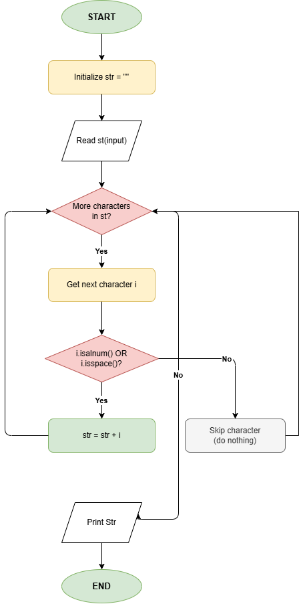

Execution:
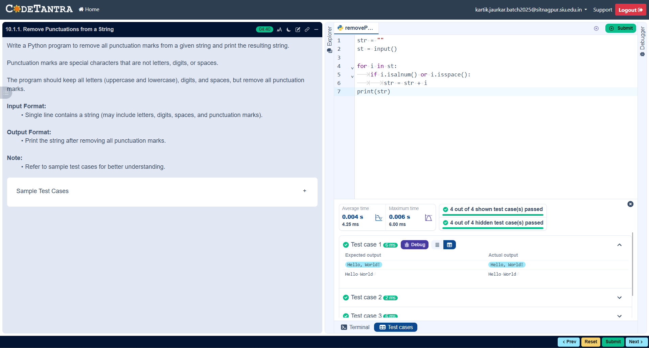

10.1.2 Reverse a string:

Algorithm:
Step 1: Start
Step 2: Define a function reverse_string(str1)
Step 3: Initialize an empty string res
Step 4: Find the length of the string str1 and store it in ln
Step 5: Loop from ln - 1 to 0 (in reverse order):
Append each character str1[i] to res
res = res + str1[i]
Step 6: Return the reversed string res
Step 7: Read input string from user and store it in user_input
Step 8: Call the function reverse_string(user_input) and store result in result
Step 9: Print the original string
Step 10: Print the reversed string
Step 11: Stop

Flowchart:
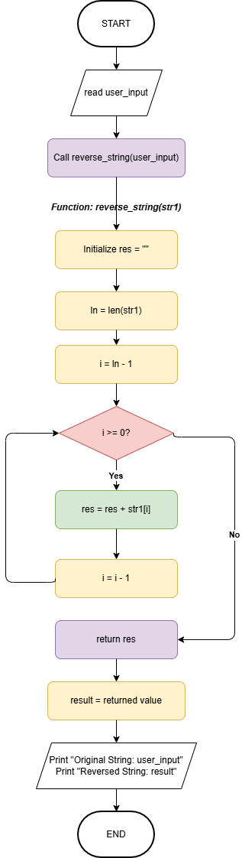

Execution:
